

Dear ADA members and friends,   
  
Happy New Year!!

We are happy to share a summary of information circulated among ADA members and friends on ADA activities and Sustainable Development Goals in January 2017  
  
This time, we would like to ask you to get connected to ADA as CSOs working on sustainable development in Asia!  
Please see below for details how to get involved and share your activities for greater impact!  
  
In solidarity,   
ADA Secretariat

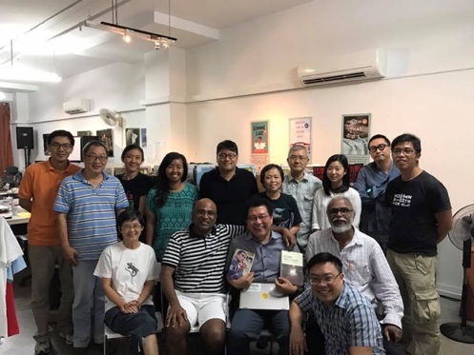**ADA and Members Activities**

**SDG Consultation-Singapore**

Asia Development Alliance (ADA) along with its partners Asia Democratic Network (ADN) and [ALMOS - Alliance of Like-Minded CSOs in Singapore](https://www.facebook.com/ALMOS.human.rights/?ref=page_internal) (ALMOS) a network of CSOs working on UPR and SDGs in Singapore including a group called "Function 8", mainly former political prisoners, organized a half day consultation on SDG and goal #16 in particular on Sunday, 15 January 2017 at 2.30 - 5pm at The Agora, #03-142, 28 Sin Ming Lane, Midview City, 573972, Singapore. For detailed report, read [here](http://koreapr.eowork.co.kr/bbs/board.php?bo_table=res01&wr_id=30)

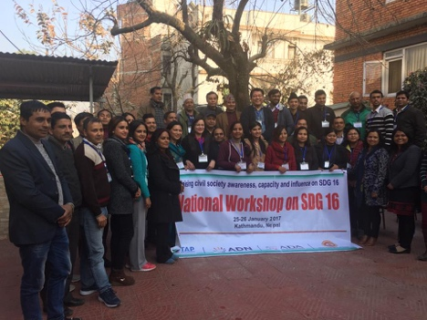 **National workshop held on SDG 16 on 25-26 January, Kathmandu, Nepal**

The civil society organizations in Nepal organized two-day national workshop on SDG goal number 16 in Kathmandu. The workshop was organized in partnership with NGO Federation of Nepal (NFN), Nepal SDGs Forum, ADA, ADN and TAP Network. Many prominent civil society organizations of Nepal attended this crucial workshop to deliberate the issues related State of Nepal's democracy in South Asia. For detailed report, read [here](http://koreapr.eowork.co.kr/bbs/board.php?bo_table=res01&wr_id=31)

**Upcoming Event**

**Regional Workshop on National Implementation of SDGs – Voluntary National Review (VNR) of UN HLPF 2017 and its annual Steering Committee (SC)** meeting at the IBIS Bangkok Riverside Hotel, Thailand on 24 and 25 (Friday and Saturday) 2017. Please read in detail [here](http://koreapr.eowork.co.kr/bbs/board.php?bo_table=res01&wr_id=32)

**For Your Action**

**Call for Participation | The Asia-Pacific Civil Society Forum on Sustainable Development and The Asia-Pacific Forum on Sustainable Development (APFSD 2017)**

The United Nations Economic and Social Commission for Asia and the Pacific (ESCAP) is convening the Asia-Pacific Forum on Sustainable Development (APFSD) 2017 in Bangkok on 29 to 31 March, 2017 on the 2030 Agenda for Sustainable Development and as a preparatory event for the High-level Political Forum on Sustainable Development (HLPF) to be held in July 2017 in New York. Representatives of civil society organisations are invited to apply to participate in the following two events:

**The Asia-Pacific Civil Society Forum on Sustainable Development:** 26-28 March 2017 in Bangkok

**The Asia-Pacific Forum on Sustainable Development (APFSD 2017):**29–31 March 2017 in Bangkok.

Please review the attached call for participation carefully and apply to participate online at <https://goo.gl/forms/RqzlJeiMphFfYbIX2>.

For details read [here](http://koreapr.eowork.co.kr/bbs/board.php?bo_table=res01&wr_id=33):

**Open Call for Asian Youth Leadership Forum for Democracy 2017**

The Asia Democracy Network (ADN) is organizing the AYLD 2017 in cooperation with, local host, the May 18th Memorial Foundation in Gwangju (15-20 May 2017) and ADN’s local members and partners in South Korea. It is a great pleasure to invite you to the first Asian Youth Leadership Forum for Democracy (AYLD) to be held in Seoul and Gwangju from 13 to 20 May 2017.Under the theme “Renewing Asian Youth Power for Democracy”, participants are expected to share their experiences of social and political engagement and to discuss common challenges to democracy in Asia to come up with a strategic action plan for advocacy and strengthening a youth network for democracy in Asia. Approximately 30 youth leaders (aged 18-30) from South, Southeast, and Northeast Asia will be invited to participate in the AYLD 2017. For detail read [here](http://koreapr.eowork.co.kr/bbs/board.php?bo_table=news01&wr_id=45)

**USAID's 2015 CSO Sustainability Index - Asia**

It reports on the strength and viability of the CSO sectors in seven countries in Asia: Bangladesh, Cambodia, Indonesia, Nepal, the Philippines, Sri Lanka, and Thailand. While overall sustainability levels for all of the assessed countries fall within the Sustainability Evolving category, this fact masks the great variations across the countries in overall sustainability and within the different dimensions of Legal Environment, Organizational Capacity, Financial Viability, Advocacy, Service Provision, Infrastructure and Public Image.

**The report can be read on** by clicking the link <https://www.usaid.gov/asia-civil-society>.

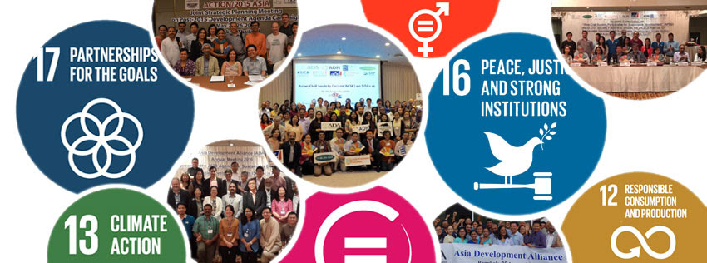

* ADA's official website has been renewed. All the information related to the implementation of SDGs in Asia and actions conducted by Asian CSOs will be accumulated on this website. Please visit www.ada2030.org
* ADA's Facebook page has been activated! The page will channel useful information among civil society actors in Asia. Feel free to tag @Asia Development Alliance in future collaboration. The page is accessible with this web address: <https://www.facebook.com/ada2030/>

